Contents
Background 1
Configuration 1
Adding a new reason code 1
Amending a reason code 3
Linking a reason code to a reason code group 3
Removing a reason code from a reason code group 5

Background
Absence Reason Codes (e.g. Sickness Absence) are linked to Reason Code Groups, which allow HR Self-service users to provide further detail about the type of absence being recorded.

Configuration

The following menu option must be enabled against the relevant menu profile:
Reason Code and Groups (723413661)

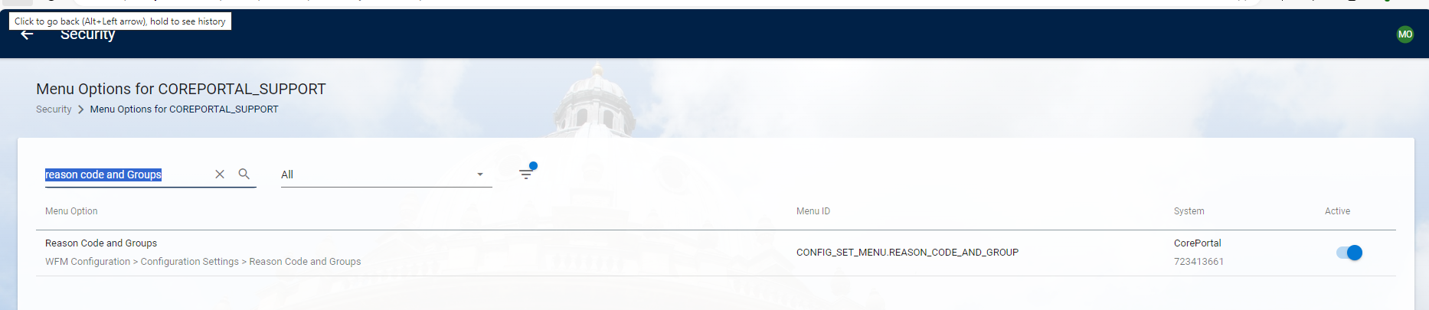

Adding a new reason code

WFM Admin Dashboard > Reference Data > Reason Code and Groups

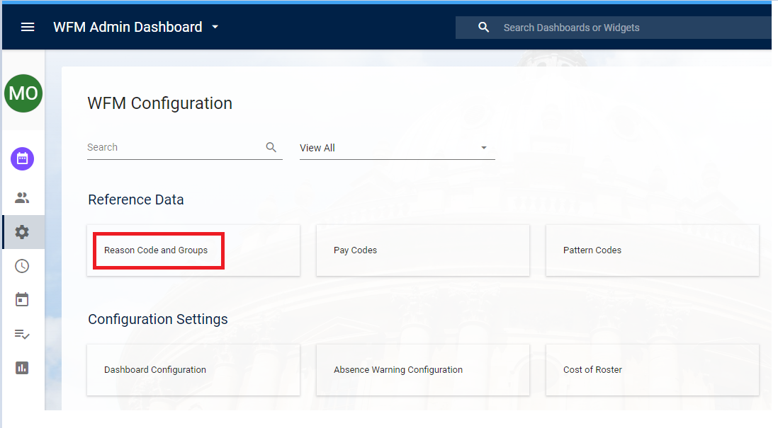

Ensure you are on the Reason Code tab

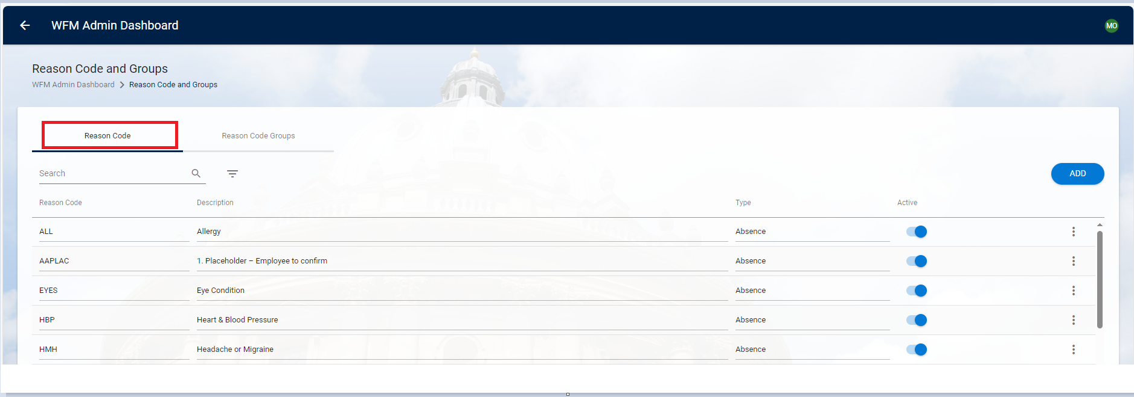

Click on ADD

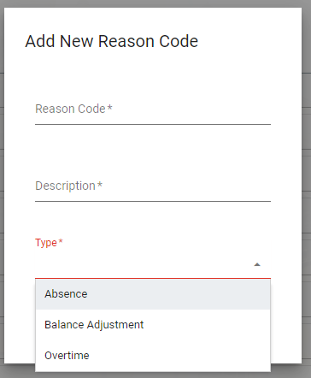

In the Add New Reason Code screen enter the details as shown:

Field | Description
Reason Code * | Enter an ALPHA code, the maximum length for this field is 6.
Description * | Enter the description
Type * | Select Absence

Click OK exit the screen. Your changes will be saved.

You will now need to link the newly created Reason Code to a Reason Code Group.

Amending a reason code

WFM Admin Dashboard > Reference Data > Reason Code and Groups

Click into either the Reason Code, Description or Type fields to make the amendment by directly overwriting the information.

Use the toggle to make a Reason Code active or inactive.

Linking a reason code to a reason code group

WFM Admin Dashboard > Reference Data > Reason Code and Groups



Click on the Reason Code Groups tab.

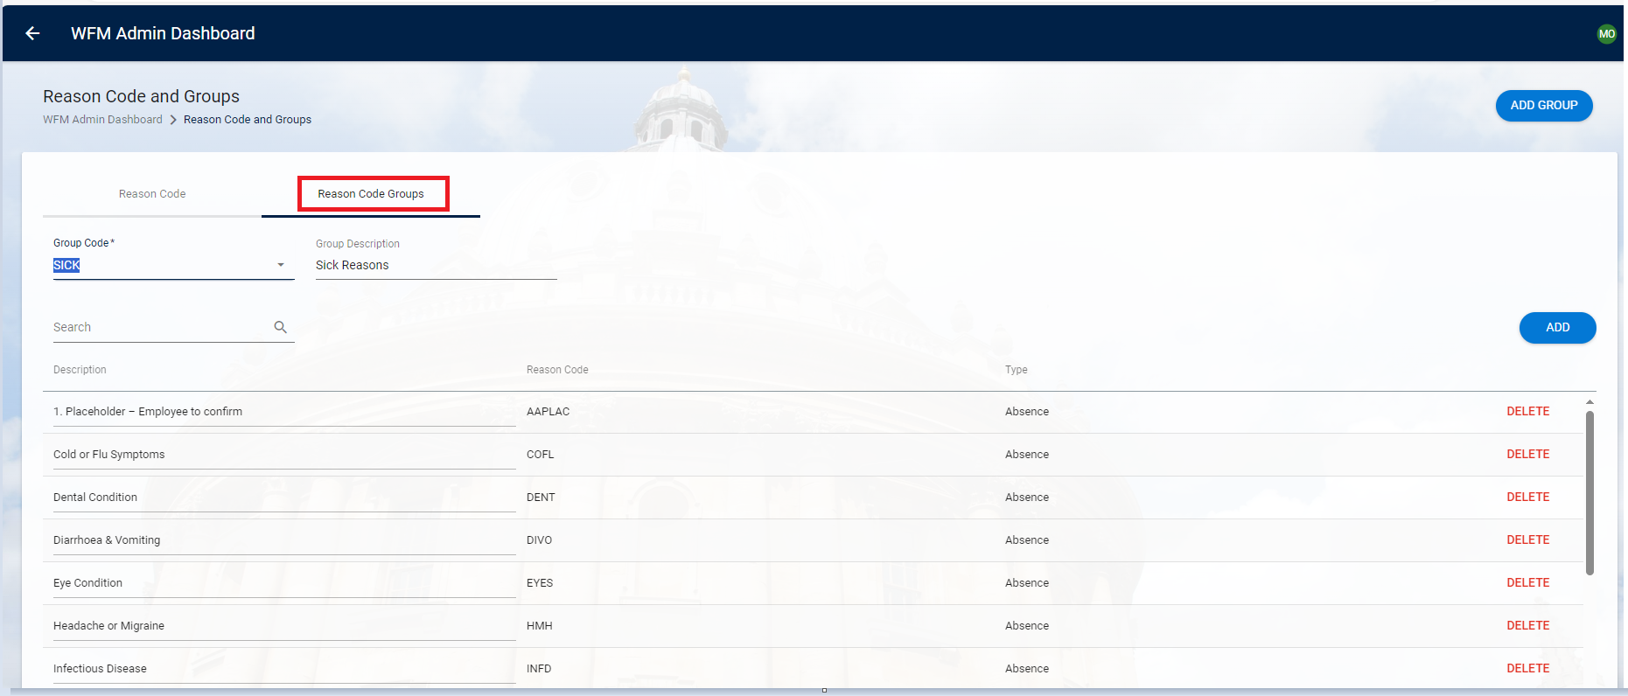

Under Group Code select SICK from the drop down list

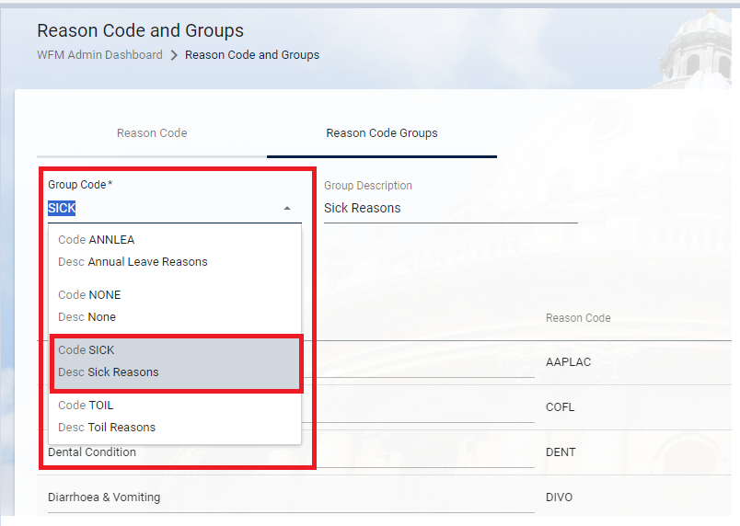

Click on ADD to insert a new row

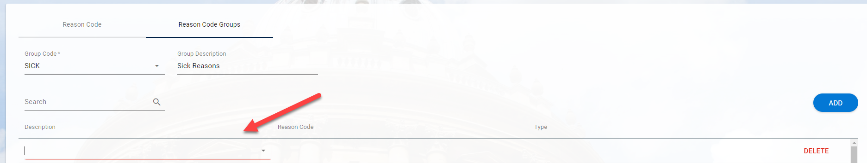

Click on the arrow in the new row to view the list of available codes.

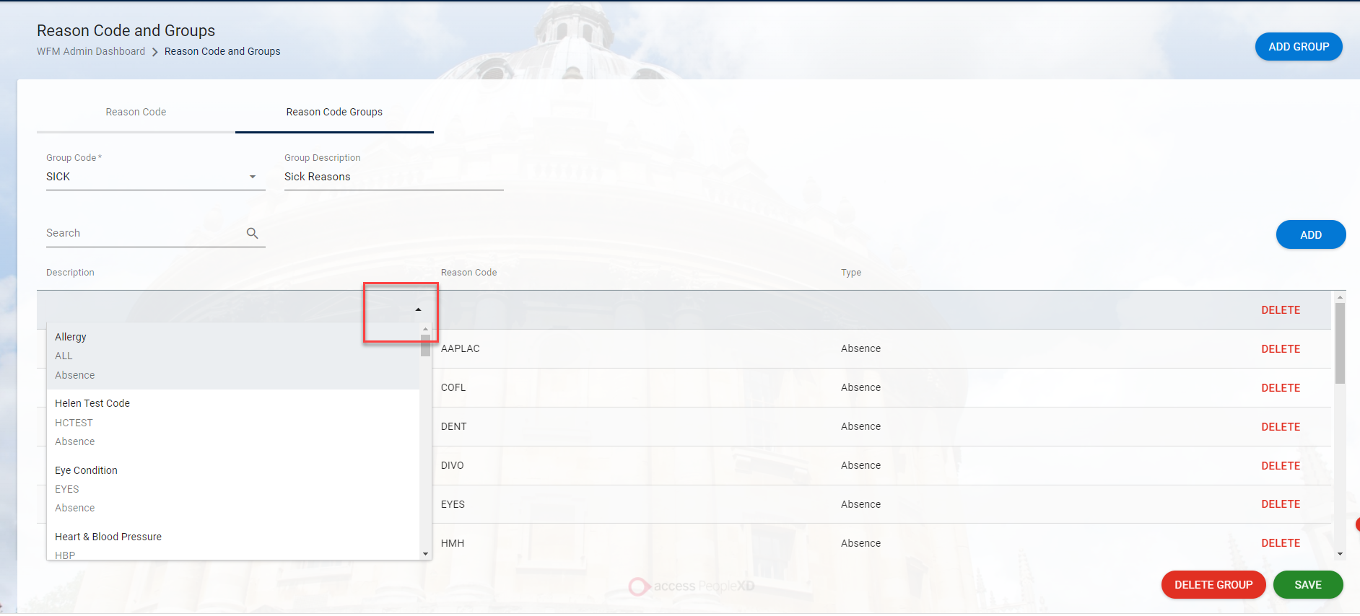

Select the code you wish to add then TAB across. The Reason Code and Type should update automatically.

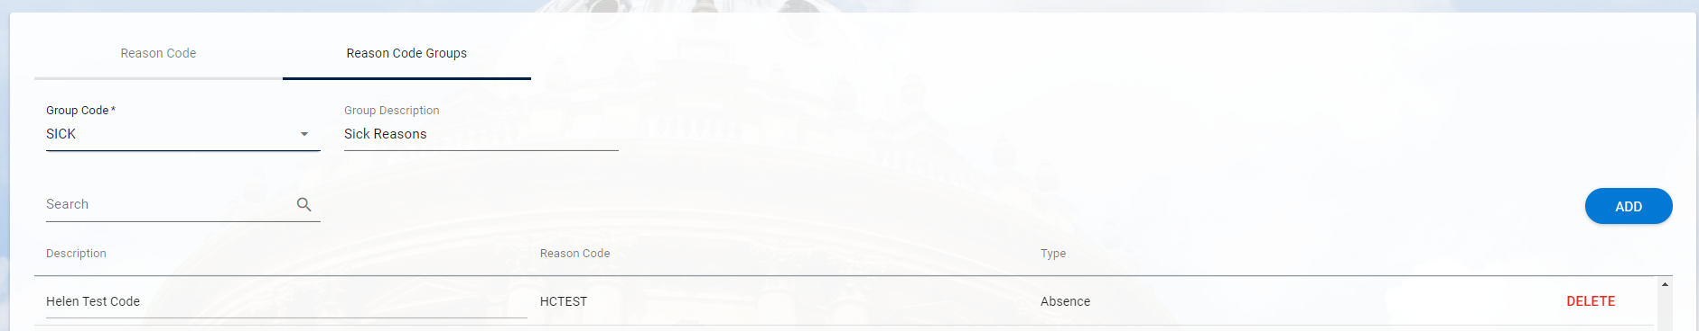

SAVE

Removing a reason code from a reason code group

WFM Admin Dashboard > Reference Data > Reason Code and Groups



Click on the Reason Code Groups tab.



Under Group Code select the relevant option from the drop down list



Search for the code to be deleted and click on DELETE

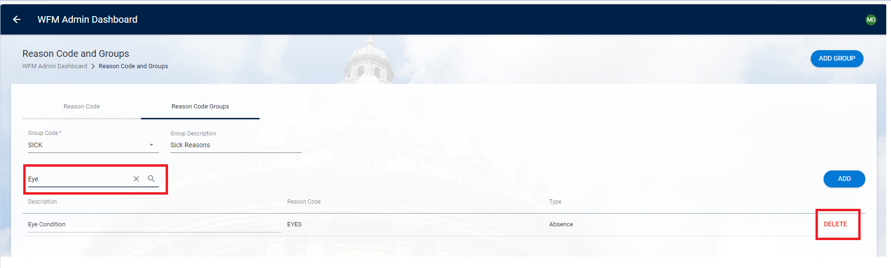

Say Yes to the confirmation message

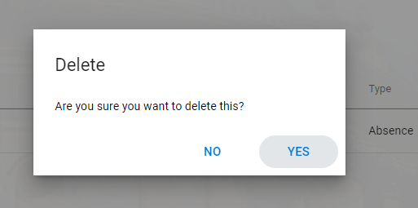

A confirmation message will appear

